Sunday 30 November Killeen 10.00 a.m.
Patrick Gavin, Glenamurra, 7th anniversary, his wife, Anne and deceased of the Gavin & Kilcoyne families.
Nonie and Martin Keane, Feenone, 10th & 29th anniversaries.
P.J Kilcoyne, Killadoon
Michael and Nora Lyons, Martin Mannion and the deceased of the Lyons and Mannion families, Killadoon.
Sunday 30 November Louisburgh 11.30 a.m.
Thomas Prendergast, Month’s Mind.
P.J. Burke, 4th anniversary and his wife Moira, Bunowen.
John and Sarah Kilcoyne and deceased of the Kilcoyne family. Furmoyle.
Mike and Bridgie Kelly and the deceased of the Kelly family, Furmoyle.

R.I.P. Pray for Billy Nelis who died recently in Chicago, husband of Ann (nee McLoughlin) Falduff, and Brother in-law of John McLoughlin,
Falduff.

Monday December 01 No Mass
Tuesday December 02 10.00 a.m.
Wednesday December 03 10.00 a.m.
Thursday December 04 10.00 a.m.
Friday December 05 10.00 a.m.

Liturgical Ministers in Killeen December
Reader : Martin Jennings
Eucharistic: Bridget Donnelly
Liturgical Ministers in Louisburgh December 07
Reader : Maria Hastings
Eucharistic: Agnes Cox, Mary B Durkan

Adoration in Louisburgh Church: Wednesday Mornings 10.30 a.m. to 11.30 a.m.

Adoration, in Killeen Church: Monday evenings, 7.00 p.m. to 8.00 p.m.

Sunday 07 December Killeen 10.00 a.m.
Christy O Malley, Curramalley, 2nd anniversary.
Seamus Sammin.
John and P.J. Sammin.
Kathleen Davitt, 15th anniversary.
Sunday 07 December Louisburgh 11.30 a.m.
Martina Mitchell, Month’s Mind.
Patrick and Mary Mulchrone, Newport.
Bridget Hannon, Bunowen, her husband , Tom and deceased of the Hannon family.

Sick calls
If anyone would like fr. Nelson to attend the sick at their home, phone the parish office on
098 66198.

Louisburgh Choir Practice Monday nights 6.30 p.m. to 7.00 p.m. New members welcome. Children from 1st class upwards.

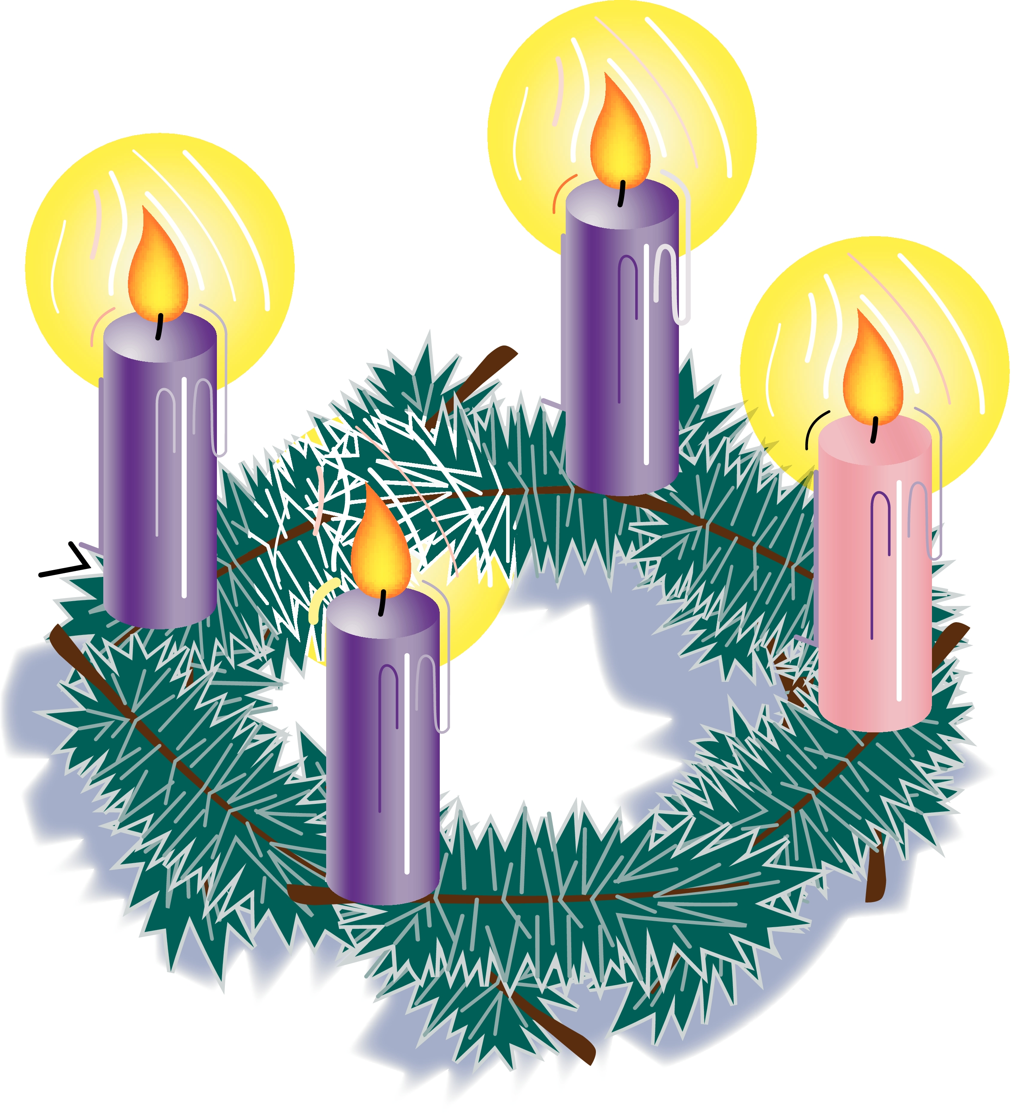
Advent Wreath:
Traditionally, the wreath is made of four candles in a circle of evergreens.
Each day, the candles are lighted, one candle the first week, and then another each succeeding week until Christmas. A short prayer may accompany the lighting.
Prayers on Lighting the First Candle on your Advent Wreath during the First Week of Advent
Lord, our God,
we praise you for your Son, Jesus Christ:
He is Emmanuel,
the hope of all people,
he is the wisdom that teaches and guides us,
and he is the Saviour of every nation.
Our Father ... Hail Mary... Glory be to the Father
Lord God, let your blessing come upon us
as we light the candles of this Advent wreath.
May the wreath and its light
be a sign of Christ's promise to bring us salvation.
We ask this through Christ, our Lord. Amen.

Altar Servers: Louisburgh and Killeen Church’s invite any children who have received their first holy communion and are interested to be Altar servers, their parents are welcome to contact the parish office on 098 66198 or email louisburghparish@icloud.com

St. Vincent de Paul:A sincere thanks to all who donated to our annual collection. A total of €1,791.60 was collected.
St. Vincent de Paul: For assistance, please contact 087 921 0885 in confidence.

Web Cams – Recording: The cameras in both churches are set up only for the live streaming of Masses. There is no facility for recording events in the churches. However, most mobile phones, tablets and computers have the facility to record what is being watched on the screen if people wish to record certain events.

Prevention of illness and infections during winter
Hand Sanitiser and face masks are available at the entrances to the churches for who may wish to wear them; many do so in crowded settings because of an underlying medical condition or because of a compromised immune system.
- Some people are very anxious about the virus transmission. Those who want to receive holy communion on the tongue, they may come to the priest.
- A nod or wave of the hand is acceptable at the sign of peace at Mass
Killeen Bingo every Friday night in Killeen Community Centre. Doors open at 7.30 p.m., eyes down at 8.00 p.m..

Louisburgh Crafty Club: Sale of Work and Raffle on Friday 05 December from 12.00 to 2.00 p.m. in The Old Convent. A percentage of money raised will be donated to Meals on Wheels and The Order of Malta.

Fatima and Lisbon Coast. 7 nights (4 + 3) June 25th - July 2nd 2026. Special Offer ceases November 30th. Contact: 012410800.

Louisburgh/Killeen Senior Citizens and Friday Club: Christmas party on Sunday 14 December in The Old Convent after 11.30 mass.
Enjoy a delicious meal and fabulous evening of local talent. Everyone welcome.
If you would like to attend this very enjoyable afternoon, please give your name to any committee member or phone Teresa on 098 66460. Transport available if needed.

Have Your Say on the Future of Catholic Education in your School
The current Department of Education survey on the future of patronage in the primary schools will determine what schools will divest.
It is important that those who wish for a change in patronage would have their voices heard. It is equally important that those who are already satisfied with the current patronage model and who wish for a Catholic Education for their children, including sacramental preparation within school, would have their voices heard also.
For these reasons, and to ensure that an accurate picture emerges, you are invited to participate in this survey if you are a parent, guardian or a prospective parent of a primary school student. Decisions on what schools will retain or lose their Catholic patronage will be influenced by the expressed opinions of those who participate in this survey. Therefore, your opinion and the values you hold dear are important, and your voice needs to be heard about your local school. Please take a few minutes to complete the survey.
The closing date is 16th December 2025.
The survey may be accessed at www.gov.ie/primaryschoolsurvey
Archbishop Francis Duffy, Patron
18th November 2025.

Louisburgh NS Christmas Fair and Bake Sale: This Sunday 30 November after 11.30 Mass in Louisburgh Town Hall.
Please come along for a Cuppa and Support our School and bring the Children to Meet Santa.

All Night Vigil at Knock Shrine takes place on Sunday 07 December. Confessions from 10 p.m. to Midnight. Vigil takes place from Midnight to 4.00 a.m. in Knock Basilica. See www.knockshrine.ie for full programme.

