**Sunday 15 June Killeen 10.00 a.m.**

Annie Kilcoyne, Cregganbawn, 20th anniversary, her husband Thomas, their son, Michael, daughter, Anne and deceased family.

Lily Kitterick.

**Sunday 15 June Louisburgh 11.30 a.m.**

Sarah Prendergast, Emlagh, 2nd anniversary.

Paddy and Kay O Malley, Long Street, their daughters, Mary & Ann & their son, Patrick.

Owen Kilcoyne, Snr, Cahir, 15th anniversary.

Monday 16 June No Mass

Tuesday 17 June 10.00 a.m.

Wednesday18 June 10.00 a.m.

Thursday 19 June 10.00 a.m.

Friday 20 June (Louisburgh NS) 11.00 a.m.

**Liturgical Ministries** **Killeen**: **June**

Eucharistic: Noreen Staunton

Reader : Michael Joe O Malley

**Liturgical Ministries** **Louisburgh**: **22 June**

Eucharistic : Mary B Durkan, Helen Fahy

Reader : Helen Fahy

Maxwell

RR

**Please Pray for:** Teresa Corrigan, nee, Frazer, Kinnadoohy and Burnley, Lancashire, U.K., who died recently.

**Newsletter notices:** Anniversary Masses and notices for the newsletter must be sent in no later than Thursday Morning.

**Adoration in Killeen Church** Monday evenings, 7.00 p.m. to 8.00 p.m.

**St. Vincent de Paul** for assistance please contact

087 9210885.

**Holy Communion for those with Coeliac** disease;please inform the priest before Mass if you wish to receive Holy Communion in the form of bread with minimal, practically no,

gluten content, or under the form of wine.

**Keeping our Churches Tidy:** If do not wish to bring the Mass Leaflet / Newsletter home with you, it would be greatly appreciated if you would leave it on the table in the porch after Mass.

**Sunday 22 June Killeen 10.00 a.m.**

Thomas and Katherine Coyne & their son, Padraic.

**Sunday 22 June Louisburgh 11.30 a.m.**

Nora McNamara, Month’s Mind and her brother, Michael, 1st anniversary.

**Corpus Christi Procession**:

*Corpus Christi*, the feast of the Body and Blood of Christ is on next Sunday 22 June.

The traditional Corpus Christi Procession through the town with the Blessed Sacrament will take place, weather permitting, immediately after the 11.30 a.m. Mass in Louisburgh.

*First Communion*; all children, from the parish or visitors, who received their first Holy Communion this year are especially welcome to join in the procession.

**For your Information: Eircodes:** In case of need to contact the emergency services, especially the ambulance service, it is very useful to know your Eircode. It makes the task of locating a house or building much easier and quicker for them.

**Summer Afterschool Care Available**: Louisburgh Childcare is delighted to offer afterschool care for school-going children at Louisburgh National School through the summer. Opening hours 8:30am – 5:30pm. Care options Full-day and half-day care available.For more information, please contact  [louisburghchildcare@gmail.com](mailto:louisburghchildcare@gmail.com) or098 23655

**Drop-In Listening Service:**At Knock Counselling Centre we offer a confidential single session listening service with no appointment needed. Our Drop-In  listening service is now available on Thursdays and Sundays from 11 a.m. to 3 p.m.

Sessions are on a one-to-one basis,  in a private, safe and confidential setting.  For any queries pleasecontact[counsellingoffice@knockshrine.ie](mailto:counsellingoffice@knockshrine.ie) or phone 0949375032. We are situated next to

the Chapel of Reconciliation at Knock Shrine.

**A Sensory Friendly Mass** takes place in the Parish Church at Knock Shrine on the last Sunday of every month at 12.30 p.m. For queries and more information, contact Nicola at [faithrenewal@knockshrine.ie](mailto:faithrenewal@knockshrine.ie)

**Louisburgh Holiday Cottages:** AGM for Louisburgh Holiday Cottages is taking place at 8.00 p.m., Monday 23 June, in the main office at Louisburgh Holiday Cottages.

**Louisburgh GAA event June 2025**

Louisburgh GAA are hosting a commemorative and celebratory event on Sunday 22nd of June at1pm at the club grounds. The programme of events includes:

* The unveiling of a commemorative plaque to the original club trustees. The trustees comprised; Tommy Duggan, Seamus Durkan, Thomas Durkan, Mick Gallagher, Thomas Harney, Austin Keane, Richard Lyons, Columb McHugh, Patrick McNamara, Patrick J McNamara, William McNamara, Eddie O’Malley, Patrick O’Malley, Austin O’Reilly, Martin J O’Toole, Richard O’Toole,  John Joe Philbin, John P Sammon, Joe Staunton and Paddy Scott.

* Dedication of the club stand in memory of Johnny Fergus, Cahir.

* Launch of our newly developed club walkway.

* A celebration of the success of the Louisburgh Healthy Clubs Initiative.

Light refreshments will be provided and all are welcome.

**Water Safety:**

Be safe andenjoy our beautiful beaches, rivers and lakes these fine summer days.

* Swim within your depth. Stay within your depth.
* Swim at lifeguarded waterways.
* Always wear a lifejacket when on the water.
* Alcohol is a factor in 1/3 of drownings. Don't mix it with water activities

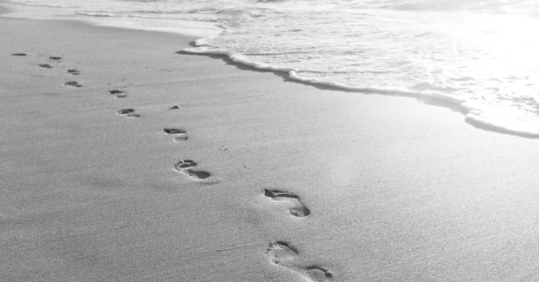 *Footprints in the sand*

*A man once dreamt that he walked along the beach, and as he walked along,   
he saw his life flash before his eyes.   
As he looked back over his life,   
he saw that for every memory there were two sets of footprints in the sand,   
one belonging to himself and the other belonging to the Lord.   
But as he looked more closely,   
he saw that for the most difficult and painful memories in his life,   
there was only one set of footprints.   
Turning to the Lord, he said,   
“Lord, when I needed you the most, why did you leave me?”   
And you might know what God said back.   
God says back, “those were the moments I carried you.”*

**Fáilte, Bienvenue, Welcome, Welkom,** 歓迎, **Willkommen, Bienvenidos,** **Benvenuto,**

**Bem-vindo, Ласкаво просимо, Powitanie**

A sincere welcome to all who are visiting the Louisburgh Killeen area this Summer and who have joined our Christian Community for the celebration of Mass in St. Patrick’s Church, Louisburgh and the Holy Family Church, Killeen.

We hope you have a very enjoyable and relaxing visit. Please exercise care while driving and when on, or near, rivers or sea and when walking in hills or mountains.

In emergency phone 112 or 999

**F.A.T.H.E.R.S.**

**F**aithful

**A**lways there

**T**rustworthy

**H**onouring

**E**ver-loving

**R**ighteous

**S**upportive

*Happy Father's Day*